a
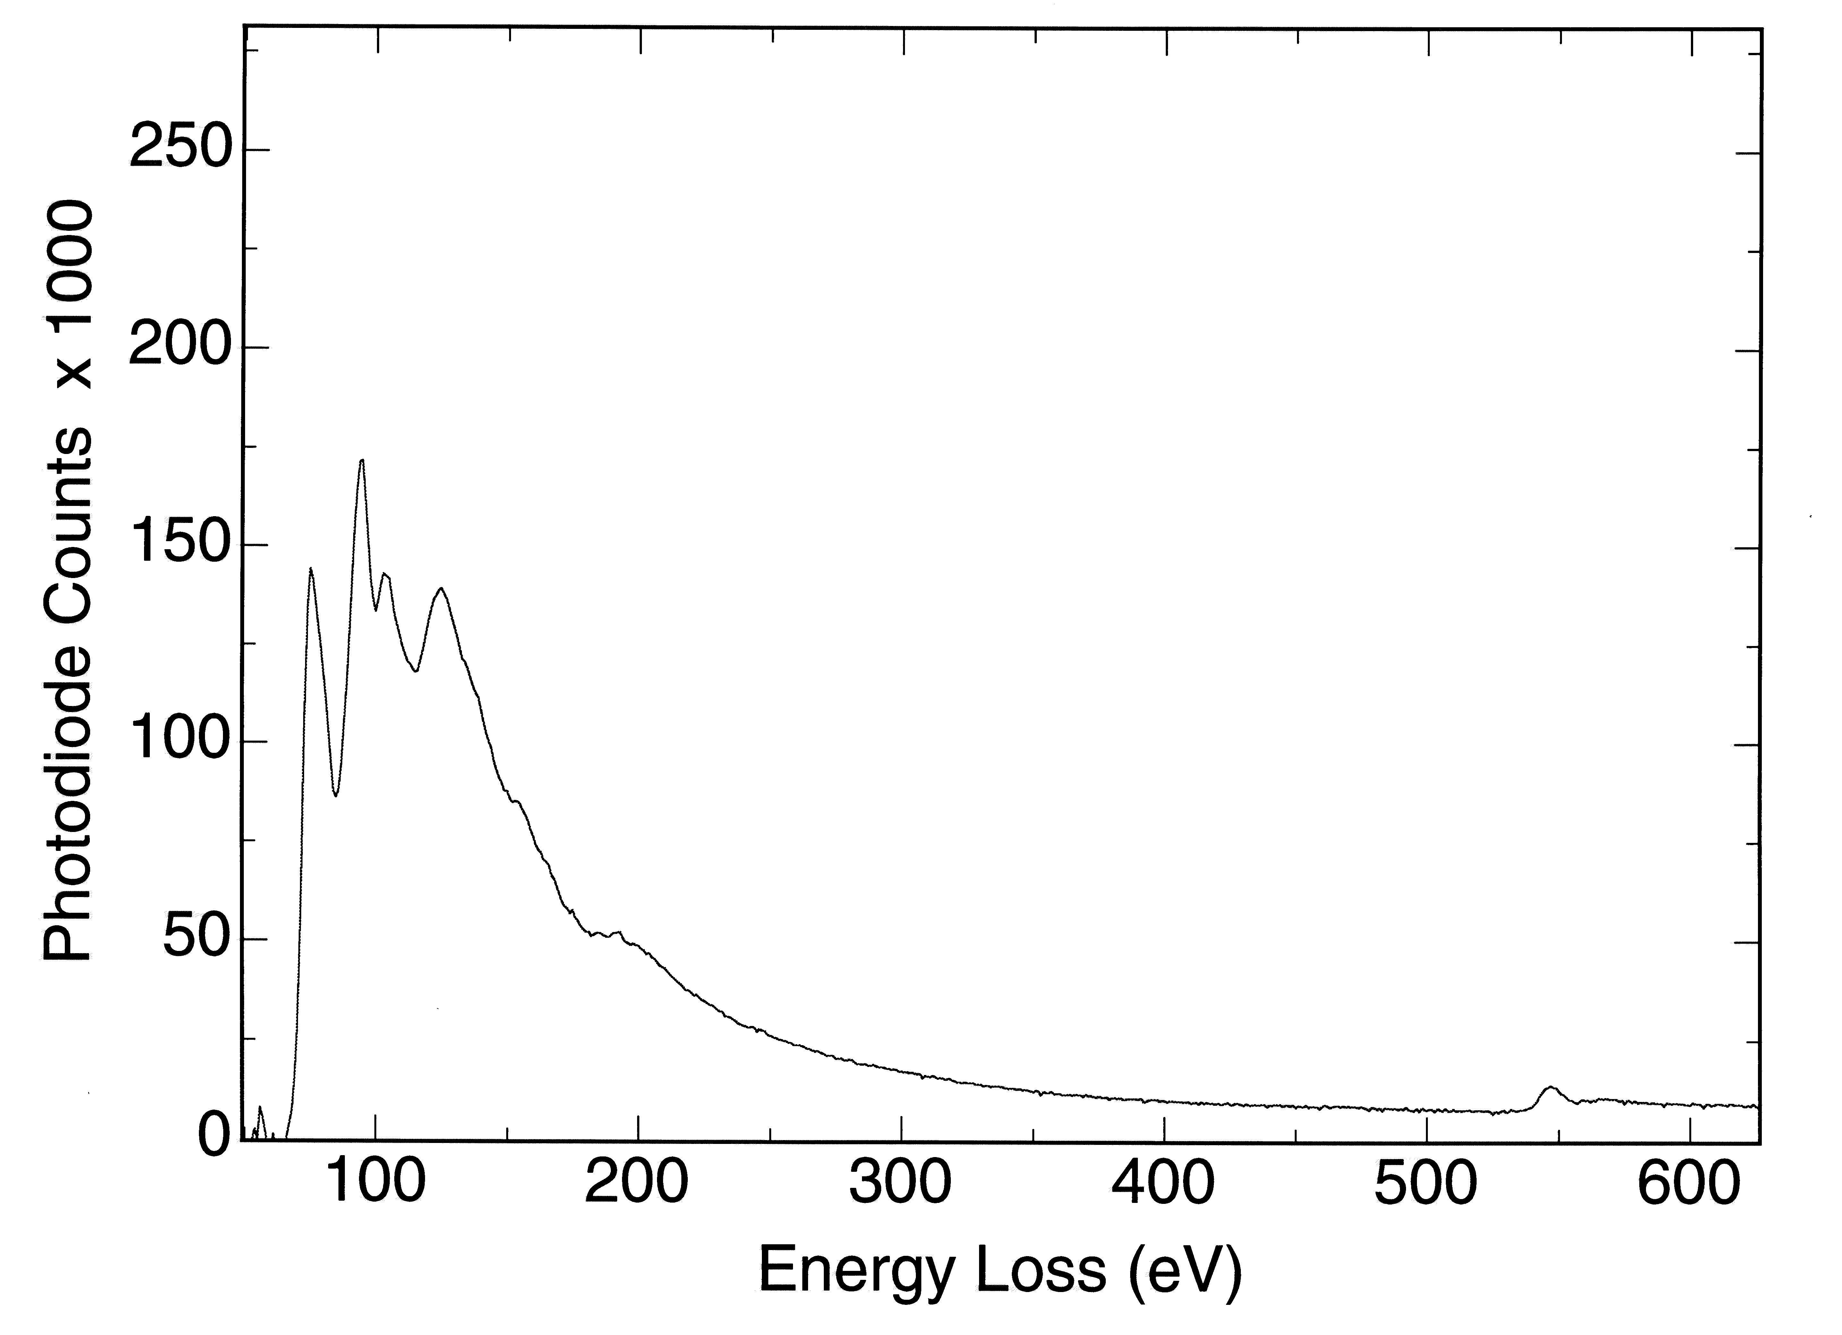
B (K)
Fiber in rose quartz

b
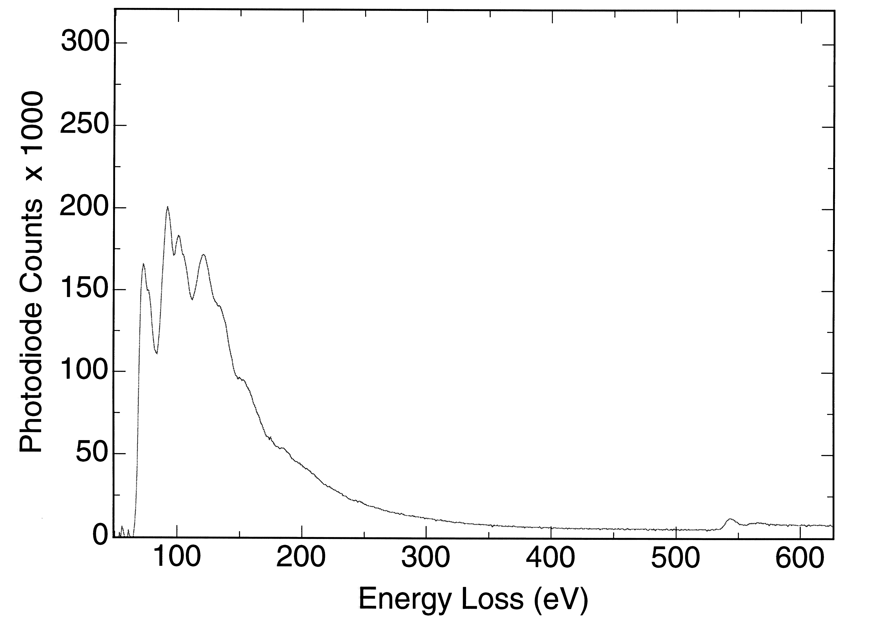
B (K)
Dumortierite

c
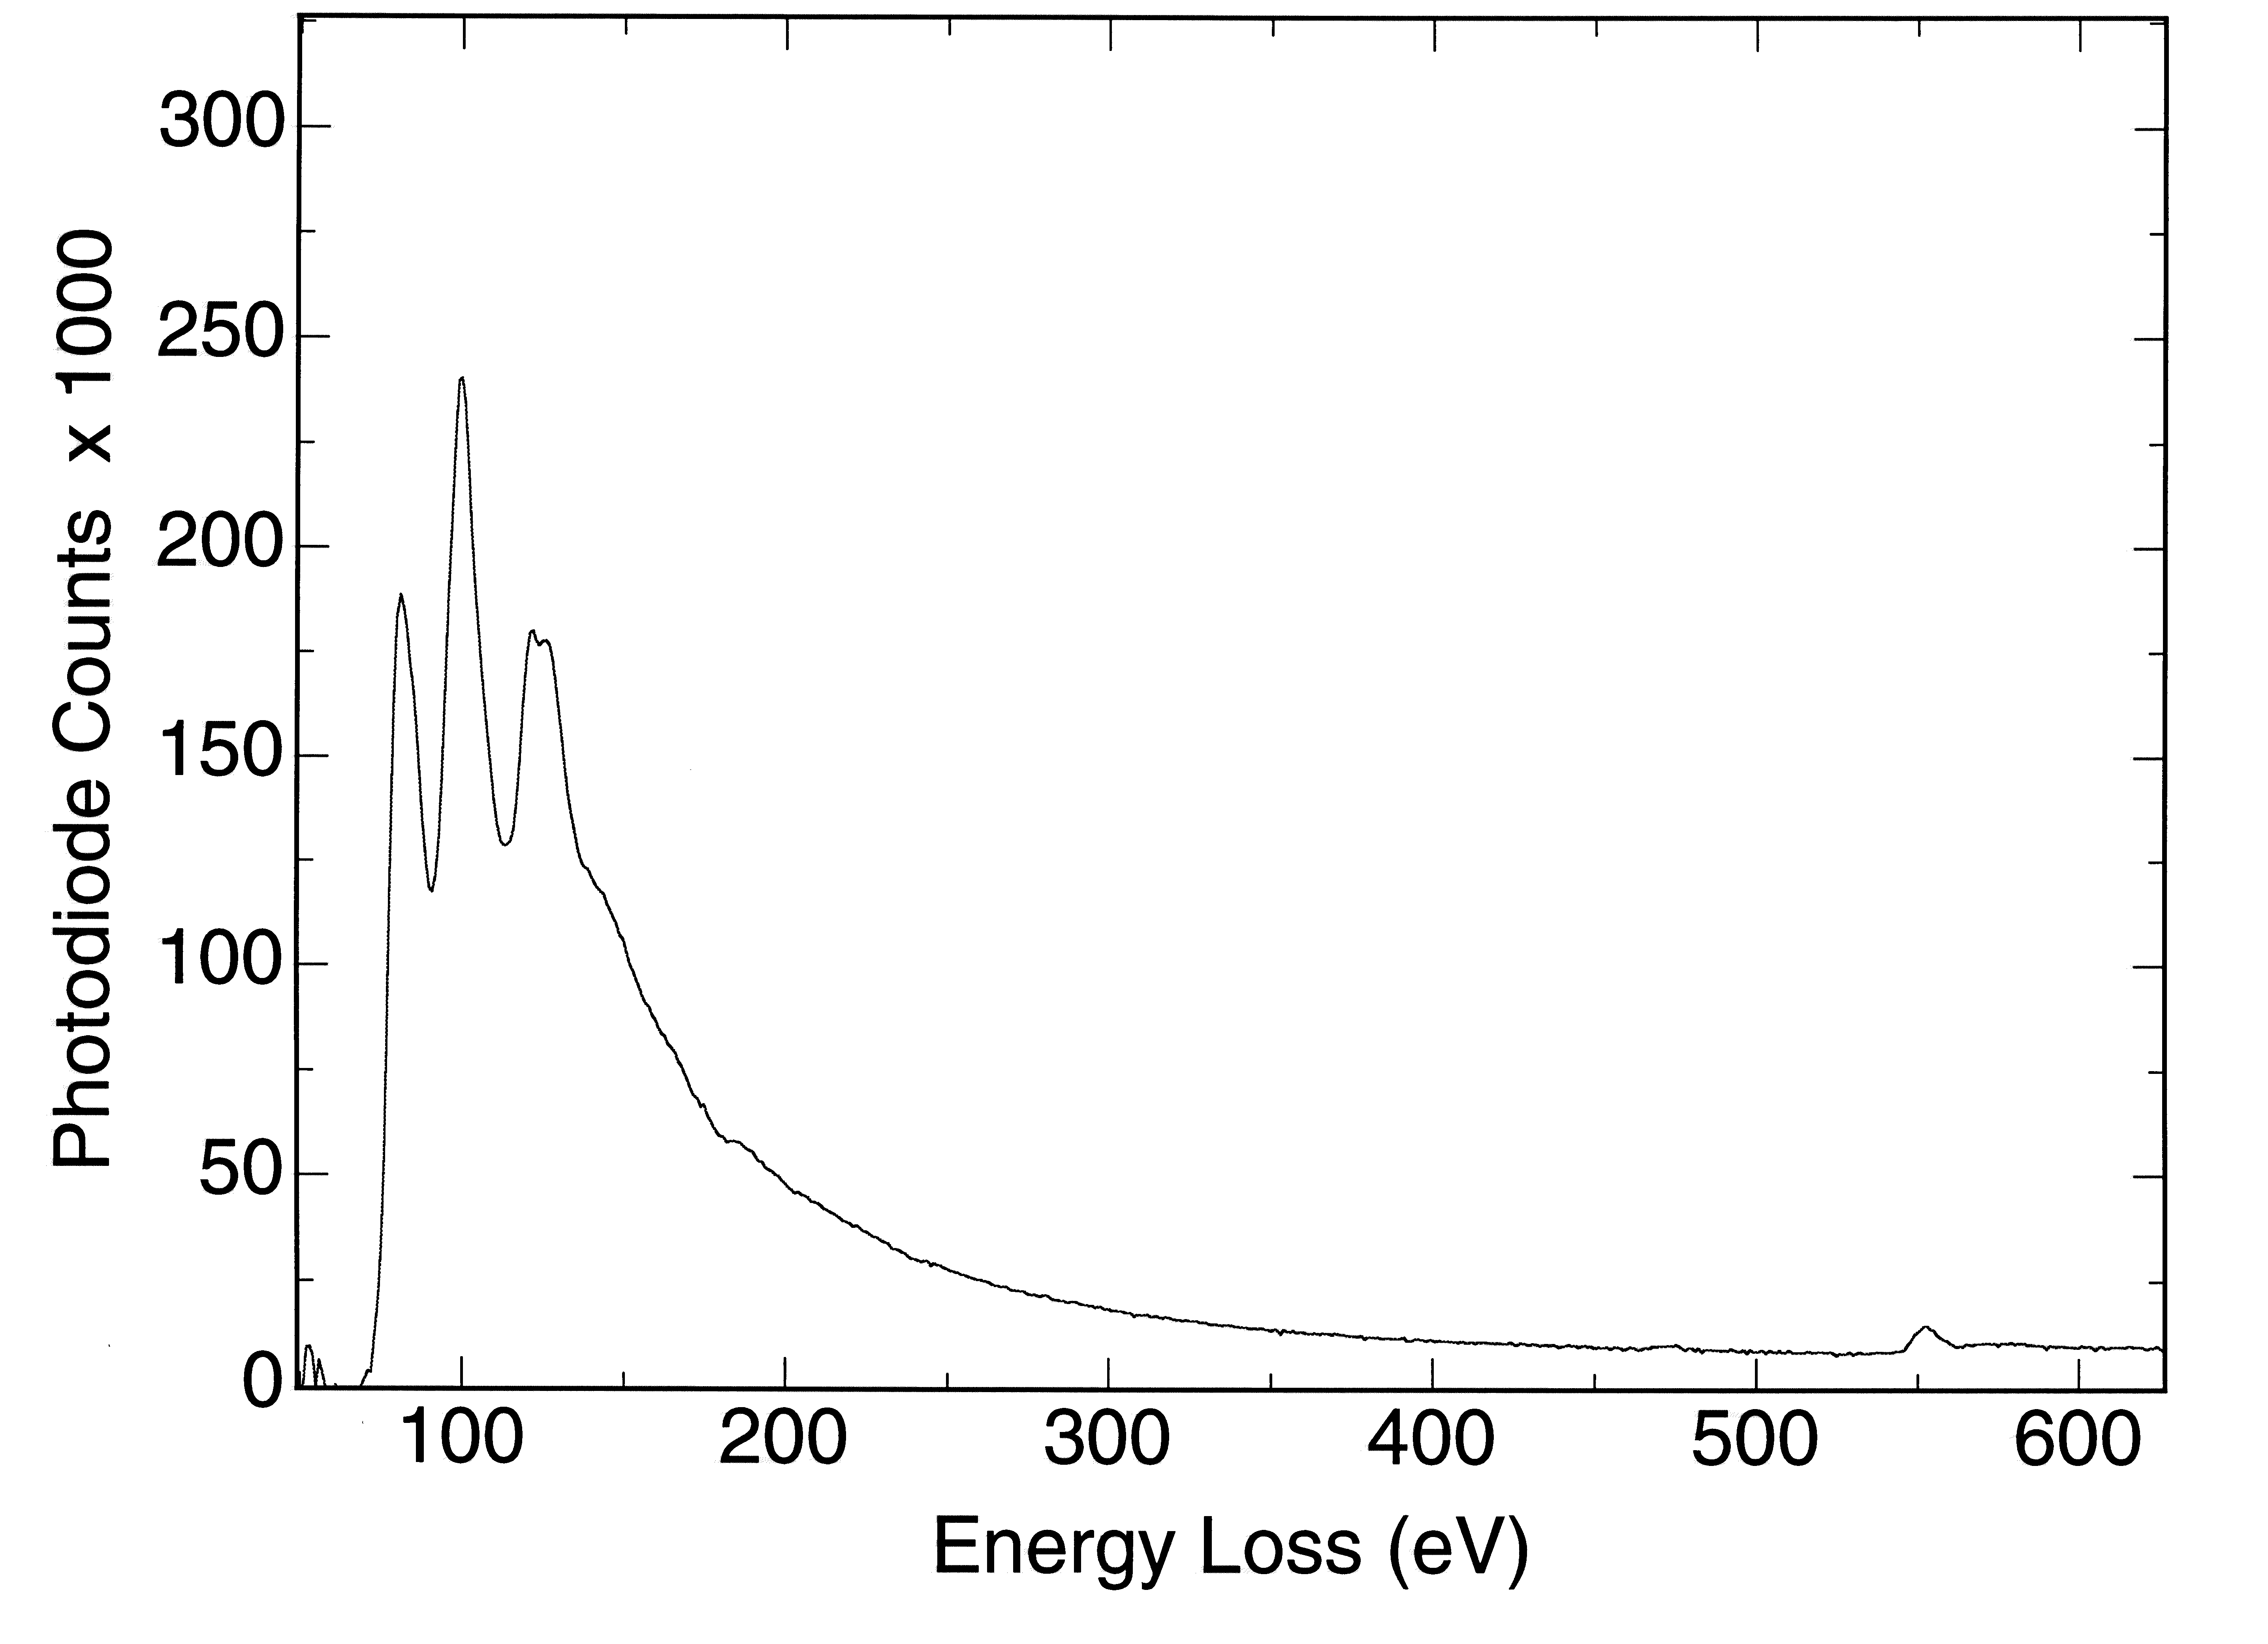
B (K)
Sillimanite

Fig. 9

