Ge 114
Homework Exercise 6
Silicates of the Earth

I) Feldspar exsolution
Consider the temperature-composition phase diagram for feldspars in the albite-orthoclase solid solution below. Beginning with a melt composition that is 80% orthoclase (Or₈₀) at 1300 ºC, draw a crystallization path cooling in equilibrium with crystals. What mineral phase(s) and compositions would we expect to exist for a cooled Or₈₀ melt? How about for an Or₁₀ melt?

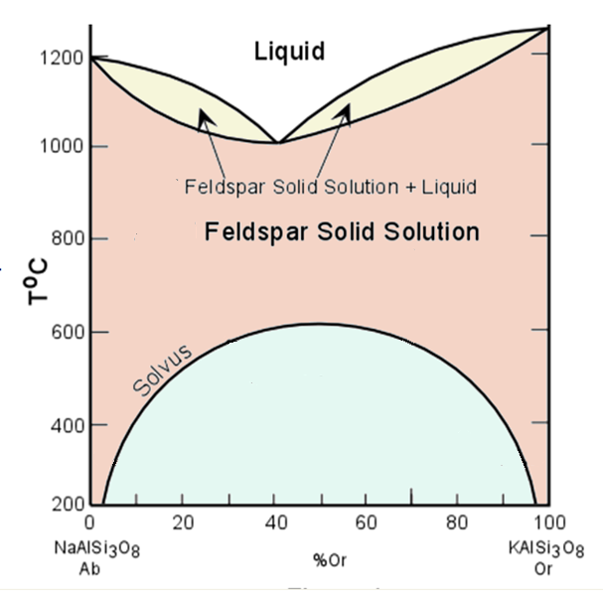

II)Silicate polymorphs
i)Below is the pressure-temperature phase diagram of the polymorphs of SiO₂. Their mineral structures can be referenced in websites such as mindat. Calculate the densities of a-quartz, tridymite, coesite and stishovite from the unit cell volumes and the number of chemical formula units per unit cell (Z) on webmineral. For tridymite and stishovite, calculate the unit cell volumes from the unit cell parameters (show work!).
ii)Refer to the structures of silica tetrahedra in each mineral. What are some notable structural feature(s) in each of the four minerals that may give rise to their densities and positions on the phase diagram?

III)Subduction
Subduction of Earth’s crust is a fundamental geologic process which has principles largely based on the material properties of minerals and the rocks they compose.

i)Basalt:
Basalt is a common volcanic rock largely composed of pyroxene and plagioclase with minor olivine and iron and titanium oxide minerals. Consider a slab of basalt composed of 62% pyroxene (augite with a composition of Ca_{0.8}Na_{0.2}Mg_{0.9}Fe²⁺_{0.2}Al_{0.4}Si₂O₆), 33% plagioclase (An₆₀), and 5% olivine (Fo₇₀). What is the density of the basalt?

The average density of Earth’s upper mantle is around 3.35 g/cm³. Compared to your calculated density, would you expect basalt to subduct?

ii)Eclogite:
When a basalt is subjected under immense pressures with moderate amounts of heat, it metamorphoses into a new rock called eclogite, which is composed of the pyroxene omphacite, garnet and minor kyanite and coesite.

Consider a slab of eclogite composed of 30 % omphacite, 65 % garnet, 3 % kyanite, and 2 % coesite, where omphacite has a composition of Ca_{0.6}Na_{0.3}Mg_{0.6}Al_{0.3}Fe²⁺_{0.2}Si₂O₆, and the garnet is a solid solution between pyrope and almandine. What is its density of eclogite for the pyrope endmember? How about for almandine?

Now compare this density with the average density of the mantle above. Would you expect any of these garnet endmember eclogites to subduct?

