GE 114a Problem Set #1
Chemical Analysis and Mineral Formulas

The purpose of this exercise is to become familiar with mineral chemical formulas and the conversion between analytical data and mineral formulas. Your textbook has several pages on an optimal way to address these types of problems.

The following four chemical analyses were obtained using a combination of wet chemical and instrumental methods of analyses. Use these data to determine the chemical formula of the minerals expressed in formula proportions normalized so that the appropriate sums of ions are small integers. The analyses are in wt% unless indicated otherwise.

Please note that is a useful and long-standing convention to report analyses in terms of oxides. In former times, chemical analyses used to consist of dissolving minerals and, after various chemical extraction and purification steps, precipitating oxides of individual elements which were subsequently weighed. Now we use a variety of other methods but still report results as oxides. In an ideal analysis, the total of all the oxides would be 100%.

You may find rruff.info/ima/ or mindat.org/chemsearch.php helpful with the list of minerals and the periodic table that you can use to select elements.

For each mineral in questions 1-3:
What is your calculated formula for this mineral?
What is its name?
What is its ideal endmember formula?

Unknown mineral #1:

A brown, crystalline mass comprised of 1-6 mm crystals is soluble in hydrochloric acid with evolution of a large amount of gas.

CaO 28.10 MgO 10.19 FeO 16.73 MnO 0.75 CO₂ 44.09

Unknown mineral #2

Recently rocks have been located in the Tianshan region of western China that contain minerals that appear to have formed at about 85 km below the surface of the Earth. These ultra-high pressure metamorphic minerals have been a focus of much study because they appear to present us with a direct probe of the mineralogy of the deeply subducted oceanic crust that is normally rarely exposed at the surface.

One mineral is slightly orangish-red and insoluble in acids. It has the following chemical formula where components are in weight:

Na₂O 0.09 MgO 1.55 Al₂O₃ 20.45 SiO₂ 37.43 CaO 7.28
Cr₂O₃ 0.14 MnO 1.23 FeO 32.32 H₂O- 0.02 TiO₂ 0.15
Use this chemical analysis to propose a chemical formula for this mineral.

Please be aware that oxidation states of the oxides expressed in mineral analyses do not always represent the correct oxidation states of the elements in the mineral. Total iron is reported as FeO. You may proportionate the iron between its two common oxidation states when you propose the chemical formula.

Unknown mineral #3

The analysis of a large crystal of a brown mineral from Yinnietharra, Western Australia, will also introduce you to "real" analyses where some analytical error is a reality of life and a little bit of many elements is a common feature of complete mineral analyses. The mineral was nearly insoluble in hot hydrochloric acid so it was dissolved by fusion in a platinum crucible using molten sodium carbonate as a solvent. For the sodium analysis, it was dissolved in molten potassium hydrogen sulfate.

Li₂O 90 ppm B₂O₃ 10.35 F 0.17 Na₂O 2.34
MgO 11.29 Al₂O₃ 32.62 SiO₂ 36.61 P₂O₅ 0.44
K₂O 0.01 CaO 1.10 TiO₂ 0.90 V₂O₅ 0.01
Cr₂O₃ 25 ppm MnO 100 ppm FeO 0.09 Fe₂O₃ 0.41
Ga 20 ppm Sr 12 ppm H₂O- 0.01 H₂O+ 3.90

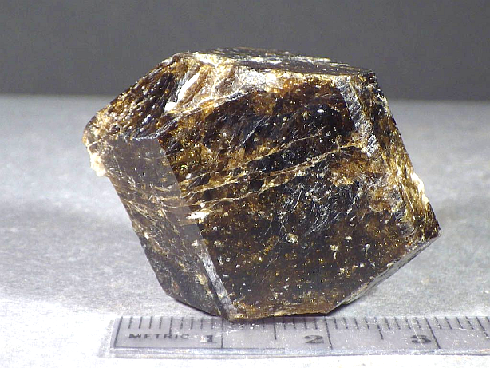
A brown crystal from Yinnietharra.

Unknown Mineral #4.

The purpose of this problem is to convert from a formula to weight percents.

A major source of the element lithium (Li) for the world in the early 1900’s was in San Diego County near the town of Pala. The mica, named lepidolite, was mined for its lithium content that was used as a component of grease, fireworks and chemicals. Now, it is being considered as a source of lithium for batteries.

How much lithium is contained in a metric ton of mica if its chemical formula is:

[K_{0.97}, Na_{0.03}] (Al_{1.48}, Li_{1.47}, Mg_{0.03,} Mn_{0.02}) (Al_{0.96}, Si_{3.01}, Fe_{0.03})O₁₀ [F_{0.24} (OH)_{0.76}]₂

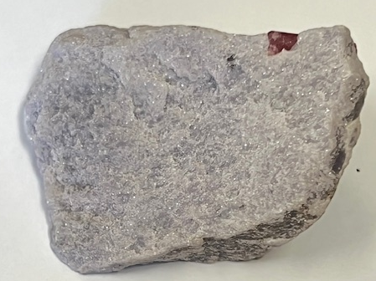
Lepidolite from Pala

