Ge 214

Homework: Uvarovite Garnet Problem
We are going to explore the spectra of a mineral taken at various pressures to become better acquainted with some of the spectroscopic parameters, and to see what type of fundamental geophysical information can be obtained from such data. The spectrum below of synthetic uvarovite was obtained at MIT in a diamond anvil cell attached to a spectrophotometer.
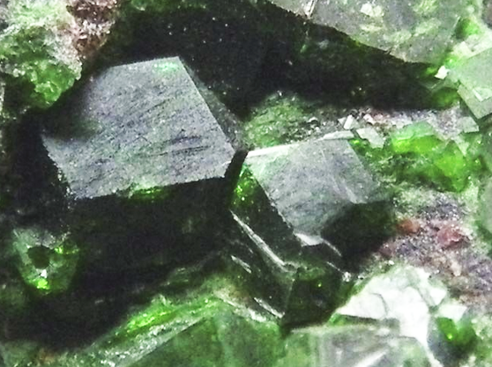
Naturally occurring uvarovite from near Jacksonville, California.

The solid line in the spectrum below was obtained at ambient pressure (1 atm); dots at 9.5 GPa;dash at 17.7 GPa.

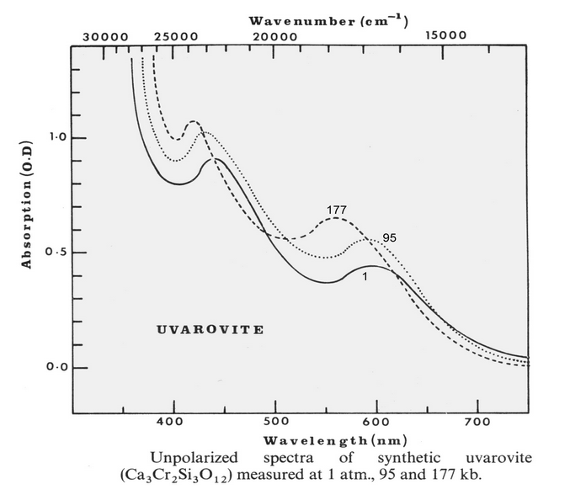
1) What element is responsible for the absorption bands in the uvarovite spectrum?
2a) In what oxidation state is that element?
2b) How many unpaired electrons does it have? From theoretical considerations, three electronic transitions are expected to occur from Cr³⁺ in octahedral coordination. They are:
⁴A_{2g} -> ⁴T_{2g}(F) designated as ν₁
⁴A_{2g} -> ⁴T_{1g}(F) designated as ν₂,
and ⁴A_{2g} -> ⁴T_{1g}(P) designated as ν₃.

These same theoretical considerations tell us that the ν₁ band will be centered at an energy equal to the crystal field parameter 10Dq (the splitting between the t_{2g} and e_{g} orbitals).
3) Determine the crystal field splitting parameter from the experimental data at the three pressures. (This means that you will have to determine which band is ν₁. Look it up; somebody has already done that job for you for a variety of related minerals and chemical compounds.)
4) Now, remember that 10Dq is proportional to 1/r⁵ where r is the metal-oxygen distance, under the assumption that the charges on Cr and O are localized on a point at the "center" of the atom (point charge model). Determine how much a Cr-O bond shortens between 0 and 15 GPa. You will need to know that the average Cr-O distance in uvarovite at ambient pressure is 1.986 Angstrom units.
5) If you assume that all bonds in uvarovite uniformly contract by this same percentage at 15 GPa, what will be the density of uvarovite at 15 GPa? The article by R. Hazen and L. Finger in the May, 1985, Scientific American discusses the inaccuracy of the uniform contraction assumption. (Compare your computed density to the value you calculate from the experimental compression data reported in Leger et al. (1990) Compressions of synthetic pyrope, spessartine and uvarovite garnets up to 25 GPa. Phys Chem Minerals 17, 161-167.)
It is generally accepted that the covalency of a metal-oxygen bond will increase with pressure because of the decrease in interatomic distances.
(a) Stephans and Drickamer, 1961, Effect of pressure on the spectrum of ruby. Journal of Chemical Physics 35, 427-429.
(b) Huggins, 1975, The effect of pressure on the covalency of ferrous-oxygen bonds. Annual Reports of the Geophysical Lab, YearBook, 74-75
The degree of covalency is measured by a parameter known as the nephelauxetic ratio, b. (The word comes from the Greek and means cloud expanding. Covalent materials "expand" their electron cloud onto their neighbors).
This parameter is the ratio of another parameter (the Racah parameter), B, in the mineral to the B parameter in the free ion (gas phase), where B₀ is the free ion value. For Cr³⁺, B₀ = 918 cm⁻¹.
(Griffith, 1964, The Theory of Transition Metal Ions. Cambridge University Press, London)

For the case of Cr³⁺, the energy of the ν₂ band is a function of the B parameter:
ν₂ = 15Dq + 7.5B - 6B(1 + z)^{1/2} where z = [(10Dq - 9B)/12B]²
6) Solve for B and b at each pressure either by analytic solution or by computer iteration.(note that the smaller B becomes, the smaller b becomes, and the more covalent the substance is).
7) Next. we need to comment on the significance of the change in b. Without a much deeper theoretical plunge, and without a lot of other experimental data, it is hard to comment on the meaning of the change in b from what data we have at hand. For now, consider the percentage change in b as a rough measure of the percentage change in the covalency of the bond. First, consider that some things go from ionic (insulators) to completely delocalized (semi-metallic, and highly covalent) with pressure; a huge change in b. Then discuss the answer to the following question: "Is an ionic model appropriate to use for minerals in the upper mantle of the Earth?"

